WILPSHIRE PARISH COUNCIL NEWSLETTER & ANNUAL REPORT MARCH 2024

Chairman’s Message
You will recently have received your Council Tax bill from Ribble Valley BC showing that each household in Wilpshire will pay £25.32 as a contribution to our Parish Council Precept. This is the principal income received by Wilpshire Parish Council and used to provide services and improve and maintain amenities within our local area.
I am pleased to report that members of Wilpshire Parish Council are very proactive in trying to enhance those aspects of the community they have responsibilities for which otherwise might not receive the same attention. At the present time, we have a very enthusiastic and committed group of councillors who work well as a team and are prepared to take on specific tasks to get them done.
I should like to remind residents that Parish Council meetings have a fifteen minute public session at the start of every meeting during which local residents are welcome to raise relevant concerns, make suggestions or seek information and advice. Parish Council meetings are apolitical. Two new councillors joined the Council last year – Gillian Munro and Howard Douglas. I should like to take this opportunity to thank our Parish Clerk, Lesley Lund, for her continuing support and advice and to thank our Parish Lengthsman, Chris Walton, who is employed to keep Wilpshire looking tidy and the garden at the traffic lights looking attractive. Also, can I take this opportunity to extend a warm welcome to new residents and hope they enjoy living in our pleasant and friendly community.
Below is information relating to work undertaken by the Parish Council as well details of services and amenities which may be of interest to Wilpshire residents.
Public Footpath Improvements
As residents will know, Wilpshire Parish Council has, for several years, been carrying out improvements to our local public footpath network. During the course of last year ten self-closing were purchased to replace awkward stiles. Nine of these have now been fitted making it much easier to use the relevant footpaths.
Before & After above Parsonage Farm
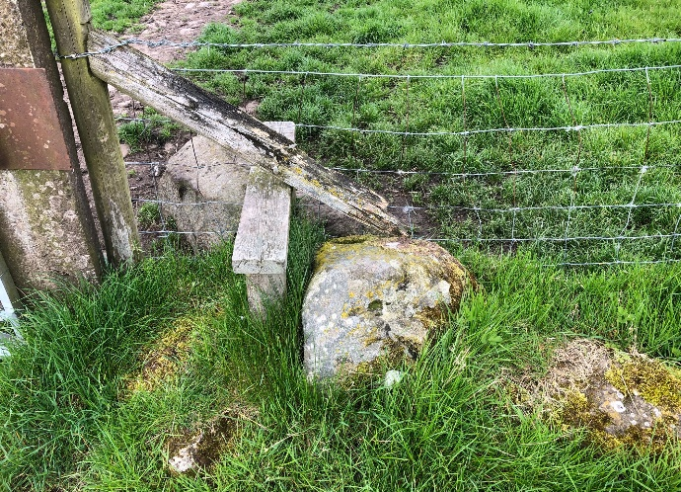
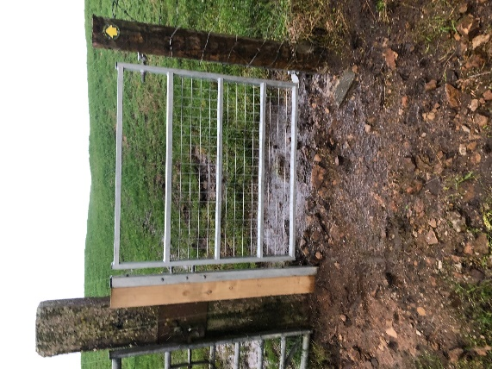

In recent months the surfaces of two well used footpaths, which were prone to flooding, have been resurfaced. These are the footpaths linking The Hazels with Vicarage Lane and the footpath leading from Whalley Rd up to the golf course. One footpath – the unofficial path leading round the periphery of properties at Wilpshire Farm at the bottom of Vicarage Lane towards Tippings Farm – has been causing concern due to reports of users slipping on the paving and on two occasions breaking limbs. The Parish Council has placed warning signs at each end on this path warning users of its hazardous surface and advising them to use the official waymarked bridlepath across the front of the properties. Thanks go to Cllr Tony Gaffney for his work in organising the footpath improvements.
Before & After – The Hazels to Vicarage Lane
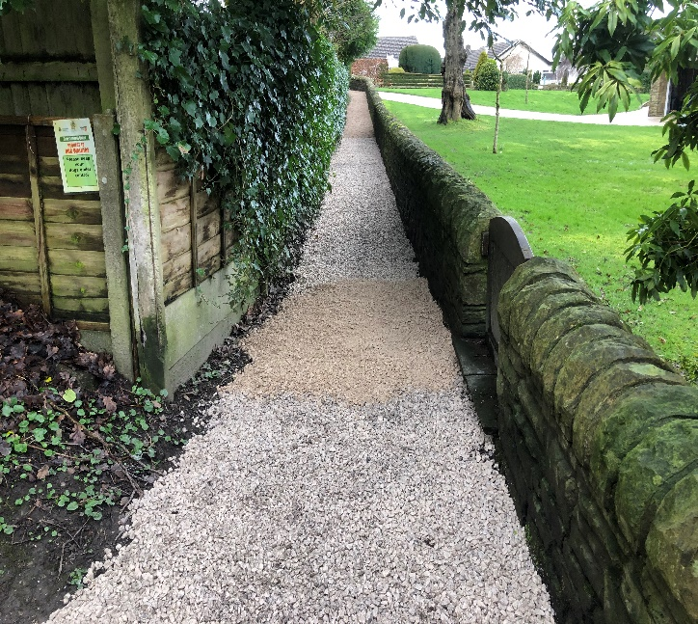
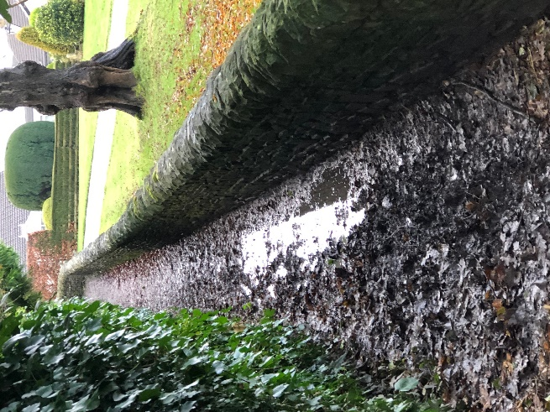

The Parish Council also receives a small grant of £500 per annum from Lancashire County Council towards footpath maintenance some of which is used to strim adjacent hedgerows and surfaces where and when necessary.

Daffodil Planting & Bird Boxes
The daffodils along the roadside verges between Wilpshire and Langho always bring joy each springtime. Other clumps of daffodils are slowly appearing around the local area thanks to the Parish Council providing money for bulb purchase. This funding has come from a £300 Biodiversity Grant applied for and received from Lancashire County Council. Some of the money has been used to purchase and install house sparrow nesting boxes on the walls of the Child Action North West Centre.
The Parish Council also provides funding for planting summer bedding in the garden at the traffic lights and in the planters on the platforms at Ramsgreave & Wilpshire Station.

Christmas Trees
For a number of years the Parish Council has provided Christmas trees to local shops and pub to brighten up the area during the darkest days of winter.
Durham Rd Play Area
The Parish Council is responsible for maintaining and, when possible, enhancing the play area located behind the properties at the bottom of Durham Rd. During the past year funding has been provided to carry out tree and equipment surveys and to pay for remedial action where necessary.
At the present time, a group of Parish Councillors has been investigating the cost of providing additional play equipment – a costly venture. The Parish Council has applied for grant funding from Ribble Valley BC towards the cost as well as using its own reserves.
Donations
The Parish Council gave small donations to locally based charitable groups who provide services to the community. These include The Little Green Bus, Bowland Mountain Rescue and The Samaritans. Wilpshire Methodist Church receives an annual room hire fee.
Local Crime Statistics
The Parish Council maintains good links with our local PCSO Caroline Pemberton. Each month the recorded crimes in Wilpshire are received. Here is the list of recorded crimes for 2023:
Drug Related 0
Vehicle Crime 3
Criminal Damage 5
Public Order 0
Anti Social Behaviour 5
Assault 0
Theft 0
Theft of Motor Vehicle 0
Burglary 3
As you can determine, Wilpshire is a very safe place in which to live. It is believed that the antisocial behaviour and criminal damage were mainly linked to one person who no longer resides in our area. The other notable statistic is theft from motor vehicles. This is one kind of criminal activity which local residents can help reduce by ensuring their cars are locked and are empty of tempting articles.
Local residents regularly express concerns about speeding on local roads and to try to address this issue the Parish Council is currently investigating the use of Speed Detectors to be placed at certain locations within the area.

Other Useful Information and Amenities
Little Green Bus
This door to door bus service provides a very convenient and useful service to those residents who have mobility problems. The service will pick up residents to take them for their weekly shop or other errands. It provides day trips to the seaside, lunch outings etc. A service of Communicars is provided to take users to medical appointments and vehicles are available for group hire. The service is manned by volunteers. New volunteer drivers are always welcome to apply. For more information call 01200 444484
Lancashire Fair Traders
Are you looking for a reliable trader? Lancashire Trading Standards Safe Trader Scheme can help you find reputable traders for property repairs, home improvements, gardening services, mobility aids etc. Further information call 0303 333 1111 or visit: safetrader@lancashire.gov.uk
Lancashire Mobile Library
The Mobile Library van visits Wilpshire every three weeks. For details of calling points and times call: 07774813452 Also, for those who can’t get out, the library service also has volunteers who will drop off and collect books to/from people at home. Please call for further details: 0300 123 6703
Public Transport
Wilpshire is served by the No22 bus service linking Clitheroe with the Royal Blackburn Hospital via Blackburn Bus Station. This service runs at half hourly intervals during the day and hourly in the evening and on Sundays. Timetables at: transdev.co.uk/blackburn
The local area is also served by the No45 service linking Blackburn with Preston via Knowsley Rd, Ribchester Rd and Longridge. This service runs at hourly intervals until early evening and two hourly on Sundays. Timetables at: prestonbus.co.uk
Ramsgreave & Wilpshire Station is served by hourly trains to Clitheroe and Blackburn/Manchester via Bolton. At Blackburn trains can be caught to Preston, Burnley, Leeds, Bradford and York and also Manchester via Todmorden/ Rochdale and stations between.
From Saturday, June 8th a new train service – The Yorkshire Dales Explorer – will call at Ramsgreave & Wilpshire before continuing via the Ribble Valley to Hellifield and stations to Ribblehead. It will run twice each Saturday throughout the year. There will be good connections at Hellifield to/from Carlisle. A programme of free guided walks will be available from the morning train. Full details at: https://communityraillancashire.co.uk/lines/yorkshire-dales-explorer/

Looking for Food, Friendship and Good Company?
Wilphire & Salesbury Lunch Club meets on the second Thursday of each month at Wilpshire Methodist Church. A two course meal plus tea/coffee is served from 12:00 to 12:30 and costs £4. Booking is advisable. Telephone Right at Home on 01254 658899
Also at Wilpshire Methodist Church every Wednesday morning between 10:00 and 12:00 you can drop in for coffee, cake and a chat.

