WILPSHIRE PARISH COUNCIL

CLERK: Lesley Lund Chair: Cllr Craig Ward
5 Hollowhead Close
Wilpshire
BB1 9LE

Email: wilpshireparishcouncil@gmail.com
Website: www.wilpshireparishcouncil.org.uk

17 January 2024

Dear Councillor

You are invited to attend the ordinary meeting of Wilpshire Parish Council which will be held on Wednesday 24 January 2024 at 7.30pm in the Wesley Lounge, Wilpshire Methodist Church, Ribchester Road, Wilpshire.
LesleyLund

Lesley Lund
Clerk to the Council

The agenda is set out below.

1 | Chair’s welcome
2 | Apologies for absence
3 | Declarations of Interest
4 | Public participation
 | DECISIONS
5 | Approval of the minutes of the WPC meeting held on 13 December 2023
6 | Footpaths and Bridleway  a] 2 additional gates Parsonage and Ashes Farm – cattle field update now complete – and photos on the website – Cllr Gaffney  b] Stepping Stones – steps – any update? Cllr Ward  c] Path up to Golf Club from A666 & Hazels footpath stoning up council to receive a rough estimate of cost. Cllr Gaffney decision and vote required Cllr Gaffney  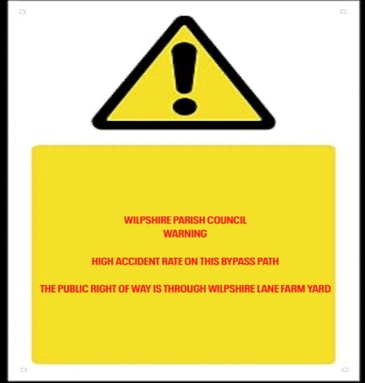  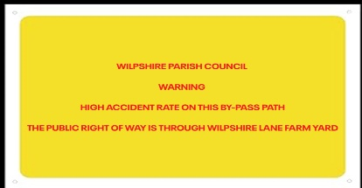  d] Bridleway – potential extra signage due to recent injuries and fall – rough prices for signs– land registry search revealed it was not registered land below Tippings Farm/Wilpshire Lane Farm  Examples of signs  Cllr Gaffney Decision and Vote required
7 | Updates and items arising from previous minutes  Min 4783/4771 Bins - update -nothing at the time of the preparation of the agenda
8 | Items for the website
9 | ACCOUNTS FOR APPROVAL  L Lund January salary £522.64 – overpayment in December £25.74 – tax £104.60 = £392.30 cheque no. 102330  HMRC £104.60 cheque no. 102331  C Walton INV-4191 £395.02 - November visits cheque no.102332  Balances  Bank - £9784.91– subject to unpresented cheques[as at 22/12/2023]  Marsden BS – 30298.44
10 | Planning Applications since the last meeting  3/2023/093 Clayton Manor Ribchester Road Clayton le Dale  Proposed construction of four one-bedroom apartments in a purpose-built detached building with separate dedicated access off Knowsley Road, following demolition of existing garage.  Planning Application - Ribble Valley Borough Council
11 | Flooding/Blocked Drains Whalley Road | Cllr Roberts
12 | Durham Road Play Area - Meeting with Sovereign took place 12 January – update.  LEF Grant | Cllrs Keegan and Munro
13 | Bio diversity grant - 3 nest sparrow box bought from RSPB. Cllr Briffett to report on meeting with CANW | Cllr Briffett
14 | PNFS – membership and grant  WPC are now a member of PNFS  Potential grant application for the stoning work at The Hazels etc and perhaps more gates for Wilpshire and local Jubilee Trail if the PNFS will pay for them. | Cllr Ward
15 | Meetings attended by councillors
16 | Network Rail – collapsed fencing behind Briars Croft – any update? | Cllr Gaffney
17 | Items for the Newsletter | Cllr Ward
18 | Speeding Ribchester Road –  Min 4883 – Cllr Foote to report re request for speed van/hand held speed device  Cllr Roberts to report re SPiDS info | Cllrs Foote and Roberts
19 | Consideration of Donations for 2023/2024 and separate donation for room hire during the financial year 2023/2024  To agree any donations for 23/24 Decision and vote required  Last years donations were as follows:  N W Ambulance £105.00  Little Green Bus £155.00  Samaritans Pay for a Day £85.00  Bowland Mountain Rescue £105.00  --------------------------------------------------------------------  To agree donation for room hire to Wilpshire Methodist Church  Last year £400.00 donation  Decision and Vote required | All
20 | To approve current Risk Assessment  Decision and vote required | Attached
21 | To approve the current Asset Register  Decision and vote required | Attached
22 | To approve current insurance requirements  Insurers are BHIB premium paid May 2023 £750.42  Decision and vote required | Details attached
23 | Any other business
24 | Next Meeting – 24 January 2024 and 6 March 2024

