WILPSHIRE PARISH COUNCIL SPRING NEWSLETTER

This shortened Newsletter is being published in an on-line form only because of the pandemic restrictions.

CHAIRMAN’S MESSAGE
When I wrote my previous Chairman’s Message back in February 2020 there was no mention of coronavirus. Back then most people thought it was still some distant threat. However, within a month the pandemic hit the UK and life changed in so many ways for all of us. Only now, twelve months later, are the prospects for a return some sort of normality brightening.

Every one of us has faced all kinds of challenges and continues to do so. The majority of the people of Wilpshire appear to have done their best to comply with the various restrictions and to support their friends and neighbours. Certainly, many have discovered new pastimes including the pleasure of walking the local public footpath network which hasn’t been used as much in decades. The improvement work carried out by the Parish Council in the past five years has certainly paid dividends.

I should like to take this opportunity to thank Wilpshire Golf Club for its liberal attitude in allowing local people to use its green spaces for exercise during the Lockdowns. It has been much appreciated by many. To acknowledge this concession, the Parish Council paid for a new kissing gate to be installed at the top of the golf course on the public footpath to Little Snodworth. The kissing gate replaced a much used stile which had collapsed in recent months due to heavy usage.

Despite the pandemic, the Parish Council has continued to function carrying out its meetings on-line. During the course of the year it has carried out further footpath improvements, revamped the traffic light garden, planted more roadside daffofdils, funded the provision of Christmas trees on local shops and redesigned our website.

We lost the services of two councillors during the past year – Martin Williams who is leaving the area and Lewis Hunter for work related reasons. We thank both of them for their support and wish them well for the future. We were pleased to welcome three new councillors to replace them – Catherine Cotton-Ambler, Gary Shulman and Dave Coleman – and hope that they enjoy their time with us.

I should like to take this opportunity to thank my fellow councillors for their work this year in difficult circumstances. They remain, as ever, an enthusiastic and dedicated team of volunteers seeking to do their best for Wilpshire. I should also like to thank our Clerk, Lesley Lund, for her support in what has been personally a very challenging year and to thank Chris Walton, our Parish Council Lengthsman, who has continued to do his job throughout, ensuring the area has been kept tidy. Thanks go to Stitch-It Ltd of Whalley for sponsoring new hi-viz clothing for Chris to wear whilst doing his jobs around Wilpshire.

Let us hope that the coming year is much brighter and that we can return to some kind of normality quite quickly. Wilpshire remains a pleasant place in which to live. Let us all continue to work together to keep it so.
Craig Ward (Chairman)

PUBLIC TRANSPORT MATTERS
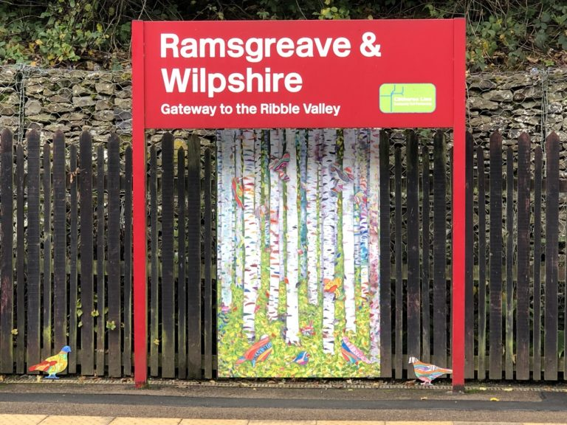
Despite the pandemic, our public transport network has continued to operate albeit with slightly reduced timetables. Of course passenger numbers have fallen dramatically but, hopefully, with the ending of Lockdown and an effective vaccination programme, will steadily increase again as confidence returns.

During Lockdown some significant improvements have taken place at Ramsgreave & Wilpshire Station. The platform shelters and platform approaches have brightened by the installation of public art panels and motifs undertaken by local college and school students under the direction of professional artist, Karen Allerton. Also, both platforms have been lengthened in order to take longer trains when demand returns or increases.
Sadly, in recent weeks, the artwork in the Blackburn bound platform shelter was vandalised.
Ribble Valley Borough Council is sponsoring a campaign under the government’s ‘Restoring Your Local Railway’ initiative to restore a regular passenger service from Clitheroe to Hellifield. The DalesRail train will commence running again on Sundays from May 16th to September 12th. Visit www.dalesrail.com for details of timetable, fares and free guided walks.
WALKING WILPSHIRE
Many people have rediscovered the delights of our local public footpath network in the past twelve months and it is hoped that this high level of usage will continue. Wilpshire Parish Council has provided two new footbridges across ditches on the footpaths leading down to Dewhursts Farm. Prior to their installation these locations were difficult to negotiate. Also, the Peak & Northern Footpath Society have installed one of their distinctive signs at the junction of paths at this location. The new kissing gate on the public footpath leading from the golf course to Little Snodworth has proved popular with users.

Parish councillors are carrying out a new survey of public footpaths in Wilpshire to identify locations where further improvement works might be carried out in future.
If you want some ideas for local walks then visit the ‘Walking Wilpshire’ page of this website.
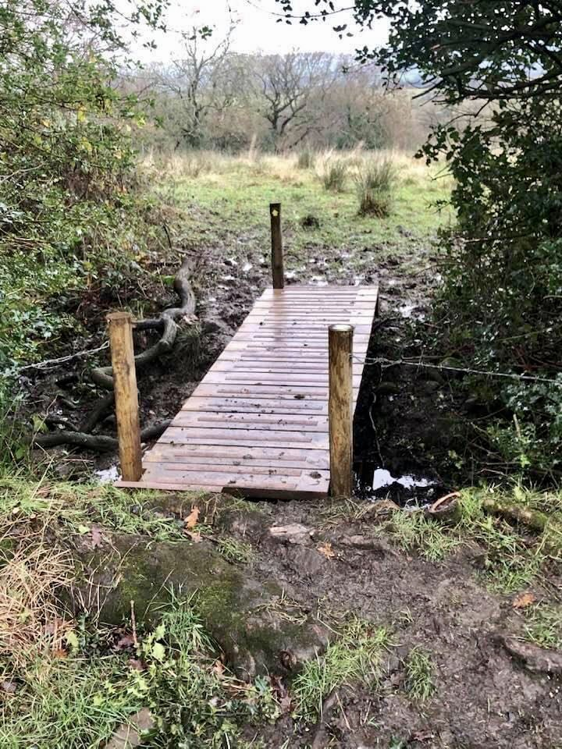
One of the two new footbridges

NEW FACILITIES AT LOCAL HALLS
Both Salesbury Memorial Hall and Wilpshire Methodist Church have been updating and renovating their facilities during Lockdown. Salesbury Memorial Hall has had new flooring, new furniture, redecoration upstairs plus overhead projection installed among other improved facilities. Likewise, Wilpshire Methodist Church has installed new disabled toilets and undertaken redecoration. Wilpshire Parish Council made donations towards the cost of the disabled toilets at both venues.These welcome improvements will be much appreciated when activities resume there.

LOCAL SHOPS & BUSINESSES

The following is a list of shops and businesses with premises open to the public.

Guys n Dolls, 5 Ribchester Road BB1 9JH
The following is a list of shops and businesses with premises open to the public.
Vicky offers a personal service in all aspects of hairstyling.
Tel. 01254 248143 @guysndollshairsalonblackburn

Deephaus Sarah Newton Designs 9 Whalley Road BB1 9LQ
Interior and exterior design service. Specialist in Kitchen, Bedroom and Bathroom design. Sarah offers either a design only service or a full service package, which includes design, project management and installation.
Tel 01254 243841 www.deephaus.co.uk

Beech’s Butchers, 11 Whalley Road, BB1 9LQ
Local butchers, distributors of meat, poultry and vegetables. A wide range of new dishes, ready meals and home-made pies is also available.
Tel. 01254 246612 www.beechs.co.uk

Right at Home, 15 Whalley Road, BB1 9LQ
Domiciliary care in the comfort of your own home.
All levels of support from personal care and assistance with day to day tasks, through to complex conditions and care needs. A 24/7 live in service is also available.
Tel. 01254 658899 office hours 24/7 out of hours mobile: 07715446095
Email: Julie.foote@rightathomeuk.com www.rightathomeeastlancs.com

Post Office Services: The nearest counters are at Spar, Portland Road, Langho and Whalley New Road, Roe Lee
Wilpshire Hotel, Whalley Rd Tel. 01254 248415

Please check for opening times and if takeaways are available
Please note: Business opening times and services will vary in line with Covid restrictions.

PROVISIONAL DATES OF FUTURE PARISH COUNCIL MEETINGS
21/04/2021 – should be annual meeting of electors , 26/05/2021 AGM, 07/07/2021, 18/08/2021, 29/09/2021, 03/11/2021, 15/12/2021, 26/01/2022, 09/03/2022, 13/04/2022 Annual Meeting of Electors, 18/05/2022 AGM

