WILPSHIRE PARISH COUNCIL

CLERK: L LUND CHAIRMAN: CLLR CRAIG WARD

ADDRESS: 5 HOLLOWHEAD CLOSE
WILPSHIRE

TEL: 01254 248289

Proceedings at a meeting held on 1 November 2017.

Present: Cllrs C Ward (Chairman), J Bremner (Vice Chairman), DBriffett, James Foote, A Gaffney, Julie Foote,M Taylor
Min No |  | Action
4626 | Apologies for absence –  An apology for absence was received from Cllr A Lund
4627 | Procedure – the Chairman reminded councillors that if anyone wished to speak to raise their hand. The Chairman also informed councillors that the standing orders and code of conduct would be distributed at the end of the meeting. Some updating needed to be done to the Standing Orders and this would be addressed by the Clerk and Chairman and brought to a Council meeting for approval.
4628 | Approval of the minutes of the meeting held on 30 September 2017.  The minutes were approved as a true record.
4629 | Updates from previous minutes  Land back of Beaver Close – lengthsman asked to clear a narrow pathway  Min 4598 - Litter Bin at entrance to Ramsgreave and Wilpshire Railway Station – the Chairman reported that a larger bin had now been fitted.  Min 4619 Insurers – the Clerk reported that BHIB are insurance brokers and they would get in touch prior to the next renewal date.  Somerset Avenue – the house at the top of Somerset Avenue appeared to have been tidied up.  Updates from County Cllr Schofield:  Bus Shelter(s), Whalley Rd - no further news. LCC public transport officers had decided to conduct bus stop(s) usage survey on Whalley Rd (in schools term time, therefore from beginning of Sep). If no update to me soon I shall issue reminder.  Whalley Rd 30mph enforcement -  Yes, Police community speed watch or roadwatch should be an option. However it may currently premature for such, as results/findings of the 2 speed & volume surveys are not yet known. You'll be aware that those surveys (each 24hrs 7days, and for both directions) were being carried out by LCC recently - for the stretch including Child Action NW hq (former orphanage) and the southern part between Wilpshire Hotel and Knowsley Rd junctn B'burn.  I'll send a reminder about those surveys.  Cllr Schofield’s view remains for the latter part which includes the bends north of Station Close, is that permanent speed cameras would be effective enforcement. The unfortunate incidence of fatalities there in recent years should be a relevant reason.  Cllr M Williams had emailed a sign to councillors prior to this meeting which was a community concern speed area sign which had LCC and Lancs Constublary logos on it and thought that this could be of interest to the Council in respect of Whalley Road:  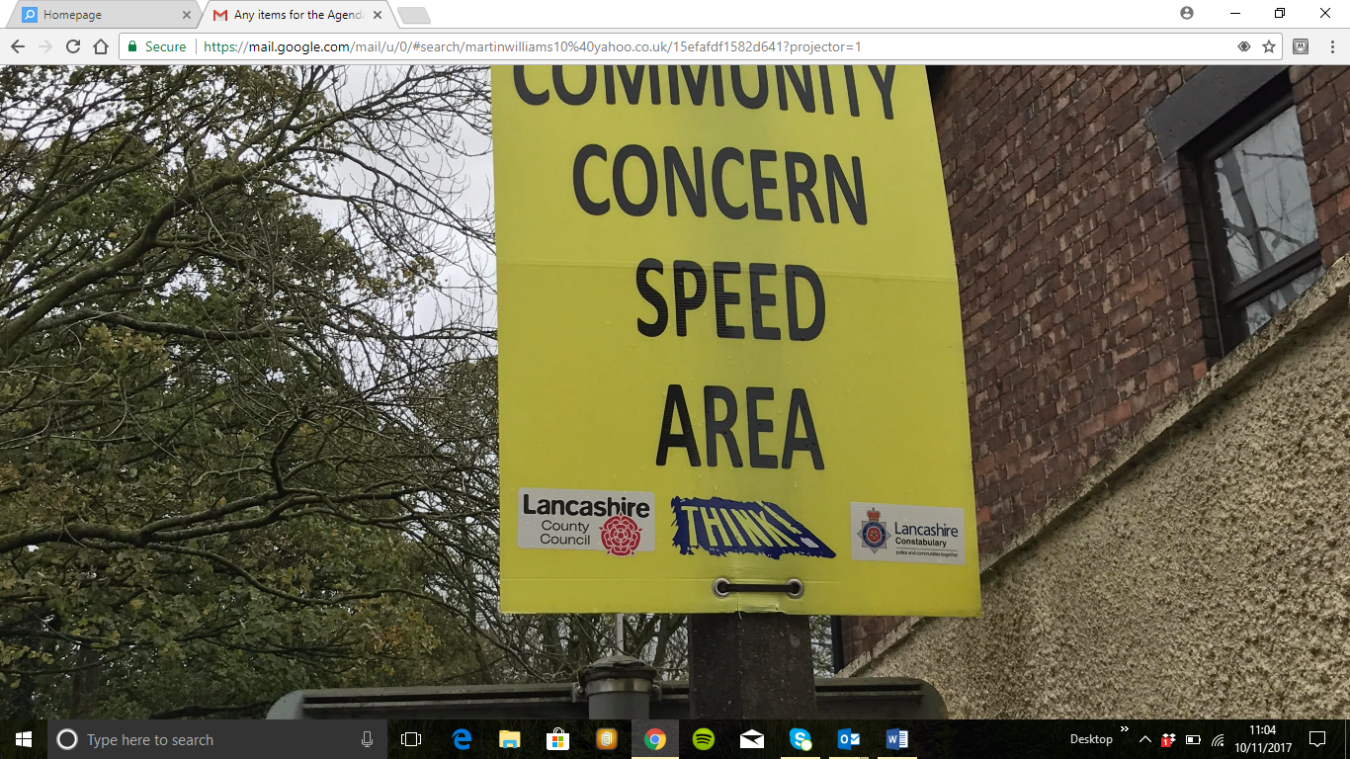  Cllr Bremner felt that there could be a use for it, if they were up for a short length of time and then removed.  Cllr James Foote agreed and added that they should be moved around Wilpshire.  Cllr Williams added that between Langho and the Bulls Head nothing stands out to confirm the speed limit of 30mph.  Cllr Shcofield’s report continued:  Knowsley Rd 20mph limit from Jun 2017 -  County Cllr Schofield copied WPC into his email to Police & LCC officers, partly as reply / acknowledgement to Cllr Gaffney, including further pursuing of extra '20' roundels markings and add'l pair of speed cushions, as requested by resident(s) from and since the design consultation stage last year.  Cllr Gaffney informed the Council that someone was doing 45mph on that stretch of road. Cllr Foote added that a road hump right across the road would slow them down.  Knowsley Rd on-street parking near to A666 junction, BwD / LCC -  I copied WPC into my update email yesterday afternoon which was partly a reply to resident.WPC felt that this had been resolved since the Co-op had opended.  There have been also issues in that vicinity with vehicles parked partly on the footway (pavement) to an extent which obstructs pedestrians etc (therefore a Police matter). As given in that correspondence, I believe that the Police, via a PCSO were taking action recently.  Former Bull's Head hotel etc in BwD (Brownhill), re-opened 19th Oct as Co-op store (described by Co-op as 'Wilpshire' Co-op) with car parking for customers -  As regards rail users parking, in addition to the existing 6 spaces (incl'g 1 for disabled) at the R&W station premises, along the stn nearest wall of the Co-op car park there are 9 spaces with overall marking 'COMMUNITY PARKING'. Presumably either somebody in BwDBC or the Co-op had come up with that marking. Per an answer to me from the site foreman, those 9 spaces are 100% for Rail Users. Apart from those 9 'community' spaces there are an actual total of 32 other spaces, incl'g 2 for disabled drivers.  Storm Brian flooding yesterday pm - eg Ribchester Rd, Wilpshire at railway bridge / nr nos. 1-5. By early evening there was significant water for traffic difficulty but later it had subsided / drained. County Cllr Schofield reported that for such a flooding notorious location the highway drains need re-investigating.  WPC commented that the A666 was also flooded.  Other - Hollow Head Lane - why HGVs' through traffic allowed ? (Ongoing issue).
2630 | Accounts for approval  L Lund October/November Salary £452.14 x 2 = 904.28– tax £180.84 = £723.44 cheque no 101885  HMRC Tax – £180.84 cheque 101901  CWalton – C0003199 £318.60 cheque no 101898  AON fragmentation policy £280.93 cheque no 101902 (extra amount due to new wooden trail)  BDO Audit - £120.00 cheque 101899  Swifts, Longridge Xmas tree lights - £83.94 (6 x £13.94) cheque 101896  Paul Mollart £60.00 (half day) strimming Little Snodworth Path – from PROW funding cheque 101897  J Omerod £30 wreath for Remembrance Sunday cheque 101904  RVBC remove Boundary Sign and install a new one near reservoir £630 (VAT £105) cheque 101903
2631 | PLANNING APPLICATIONS SINCE THE LAST MEETING  None
2632 | Meetings attended by Councillors  None
2633 | Website  Bus service changes  Recent update to the play area  Replacement of boundary sign  Local police for Wilpshire | Photos to Clerk  Clerk to contact Insp Winter
2634 | Donations for WPC and luncheon club room hire.  Also Wilpshire Methodist Church – all donations to be considered at the January meeting | January agenda
2635 | Footpath stoning/maintenance contractor estimates/prices  Just to save time at the meeting prices from Paul Mollart, contractor re footpath stoning etc.  He will work at £170 per day or the following prices, whichever is cheaper-in the past his £170 per day is cheaper than the quotes.  These prices are only for labour with Wilpshire PC providing the stone at about £400 ish inc VAT for 20T of limestone 20mm to dust.(Lesley claims the VAT back so typical cost £335 for 20T after £67 of VAT claimed back).  1-Footpath 20,non definitive footpath to steps-Hollowhead Lane, trees cut back, strimmed etc £680 labour-20T stone delivered on site by WPC. - defer  2-Footpath 9 , A666-Golf club-approx 45m £510 labour, old drainage pipe removed-Stone from Vicarage Lane/Salesbury Common near Cricket ground. Yes -Cllr Gaffney to speak to neighbours probably 10Tonnes or less  3-Hazels-Salesbury common £170 approx 6T – yes to be done  4-Vicarage Lane field FP 18,40T, £1700 delivered from Vicarage Lane - defer  5-Bridlepath 27 Overhead trees cut back inc limb off low lying hawthorn tree and branches left on site well away at the sides of the path, £120 from money provided by LCC. Yes – to be done  Also 4T of stone very muddy area east end £170-Stone Vic lane/Salesbury common. – defer  Cllr Ward proposed that items 2,3, and 5 to be done this year at a cost of approx.. £1200 . this was seconded by Cllr Briffett.  Resolved: to be done this year – Footpath 9, Hazels – Salesbury Common and Bridlepath 27 at an approximate cost of £1200.00
2636 | Wilpshire Sign – this is now in situ.
2637 | Remembrance Sunday – Cllrs Ward and Bremner will attend.
2638 | DRPA – trees , antisocial behaviour and maintenance  Cllr Bremner had had calls from resident informing her of anti social behaviour on the play are and that there had been no police response. She advised that a log should be kept of incidents.  There was also a complaint about a tree on the area behind a property and she had offered to go and view it from the resident’s side but hadn’t been contacted again as yet.  Maintenance – the information sign was still down  Grass cutting was better but still not as near to the posts as the council had requested  Ash saplings – need to be taken out they are 4-5” diameter and near to the fence
2639 | Possible suggested TPOs in Wilpshire  Cllr Briffett proposed that councillors sent photographs of trees which are possibly worthy of a tree preservation order and she could forward to the tree officers at RVBC.  The chairman read out an email from Mr Hewitt, RVBC regarding criteria for TPOs.  Cllr Williams added that it would be contentious to cut down any trees that give public enjoyment.
2640 | Housing Needs survey  The Department Communities and Local Government recently issued a consultation on Planning for the right homes in the right places. The consultation document can be found here: https://www.gov.uk/government/uploads/system/uploads/attachment_data/file/644955/Planning_for_Homes_consultation_document.pdf  NALC will be responding to consultation on behalf of the local councils that we represent and we would like you to email your thoughts to us on a number of key questions of relevance to local councils. These include:  • Question 1: a) do you agree with the proposed standard approach to assessing local housing need? If not, what alternative approach or other factors should be considered?  b) how can information on local housing need be made more transparent? The proposed approach is detailed on page 10 of the consultation.  • Question 2: do you agree with the proposal that an assessment of local housing need should be able to be relied upon for a period of two years from the date a plan is submitted? The proposal is detailed on page 15 of the consultation.  • Question 3: do you agree that we should amend national planning policy so that a sound plan should identify local housing need using a clear and justified method?  • Question 5: b) do you consider that authorities that have an adopted joint local plan, or which are covered by an adopted spatial development strategy, should be able to assess their five year land supply and/or be measured for the purposes of the Housing Delivery Test, across the area as a whole?  c) do you consider that authorities that are not able to use the new method for calculating local housing need should be able to use an existing or an emerging local plan figure for housing need for the purposes of calculating five year land supply and to be measured for the purposes of the Housing Delivery Test?  • Question 7a) do you agree with the proposed administrative arrangements for preparing the statement of common ground? The proposed administrative arrangements are detailed on page 25 of the consultation.  b) how do you consider a statement of common ground should be implemented in areas where there is a Mayor with strategic plan-making powers?  c) do you consider there to be a role for directly elected Mayors without strategic plan-making powers, in the production of a statement of common ground?  • Question 8: do you agree that the proposed content and timescales for publication of the statement of common ground are appropriate and will support more effective co-operation on strategic cross-boundary planning matters? The proposed content and timescales are detailed on page 26  • Question 9a) do you agree with the proposal to amend the tests of soundness to include that:  plans should be prepared based on a strategy informed by agreements over the wider area; and  plans should be based on effective joint working on cross-boundary strategic priorities, which are evidenced in the statement of common ground?  b) do you agree to the proposed transitional arrangements for amending the tests of soundness to ensure effective co-operation? The proposed transitional arrangements for amending the tests of soundness are detailed on page 27 of the consultation.  • Question 11: a) should a local plan set out the housing need for designated neighbourhood planning areas and parished areas within the area?  b) do you agree with the proposal for a formula-based approach to apportion housing need to neighbourhood plan bodies in circumstances where the local plan cannot be relied on as a basis for calculating housing need? The proposal for a formula based approach to apportion housing can be found on pages 31-32 of the consultation.  • Question 12: do you agree that local plans should identify the infrastructure and affordable housing needed, how these will be funded and the contributions developers will be expected to make?  • Question 17: a) do you agree that local planning authorities should set out in plans how they will monitor and report on planning agreements to help ensure that communities can easily understand what infrastructure and affordable housing has been secured and delivered through developer contributions?  c) how can local planning authorities and applicants work together to better publicise infrastructure and affordable housing secured through new development once development has commenced, or at other stages of the process?  • Question 19: having regard to the measures we have already identified in the housing White Paper, are there any other actions that could increase build out rates?  Local councils are at the very heart of their local community and that is why NALC thinks it is vital we hear from them.  The deadline for responses to us is 5pm Friday 27 October. – the Clerk had checked with LALC re this date but it should be ok if we send our comments after this as date for responses is in November .  Cllr Bibby said that individual councils would look at their own surveys in conjunction with their Core Strategies. The Housing Needs were quite different now as they had almost reached the numbers and in the Core Strategy will be reviews. Neighbourhood plans also looked at types of houses and preferred locations.  Cllr Ward asked if there would be any opportunity for Wilpshire to have another Housing Needs Survey done by RVBC.  Cllr Bremner was concerned because need and demand were two different things and brought to the attention of the Council the affordability formula mentioned based on house prices and wages. In this area most people have higher salaries by commuting out of the borough than people who actually work within it.  Cllr Bibby agreed there was a mis match at the minute and Cllr Bibby would put the points forward.  Resolved: The Chairman thanked Cllr Bibby for her explanation and offer to put forward the Council’s concerns.
2641 | Completion of Audit – The Clerk informed the meeting that the Certificate has been received and posted in the noticeboard and on the website together with the annual return. BDO LLP will not be our auditors for 17/18 and the appointed auditor can be found at localaudits.co.uk They thanked the Council for their assistance over the years they have worked with us.  There were no items to bring to the council’s attention.
2642 | Newsletter – allocation of jobs and deadline:  Chairman – Editor  Cllr Bremner – proof reader  Deadline for articles 31/1/18  Cllr Gaffney – article Wilpshire Boundary Sign/Sketch map of paths we have improved and what is hoped to be improved  Cllr Briffett – Cover
2643 | Xmas Trees Scheme – update lights battery LED received, trees ordered brackets will be going up soon. Grant offered is £217.00 so works out: Cost of scheme - £432 – grant £217 = £215 which means cost to WPC £90.00 (trees) balance is £125 shared by the 6 businesses = 20.83 rounded up to £21 each and businesses to sort taking down the trees with the contractor Mr Tomlinson. - Noted
2644 | PRECEPT  Working/Running costs of Council  Website 30.00  Clerk 5319.00  Insurance AON 715.00  Play Area repairs approx. 1000.00  Allianz play area ins/inspection 985.00  Total 8074.00  ---------------------------------------------------------------------------------------------  Receipts 34900.00 incl PROW and Champ grant  Spent to 1/11/17 19712.91  ---------------  Total 15187.09  Monies still to pay  Play Area repairs 1385.00 (noticeboard goal posts)  Est spend to 31/3/18 4299.00  ---------------  Est B/Fwd 01/04/18 9503.09  Please remember there will be VAT to claim back for this year 16/17 plus concurrent function grant 16/17 hopefully.  If we use the £3000 in the budget 16/17 for paths then the b/fwd balance will reduce to 6503.09  Band D 17/18 = £15.44 (parish) Tax base 18/19 = 1078  The above figures do not include any donations to be decided in January including room hire – Wilpshire Methodist Church  The Council discussed the presented figures and it was proposed to increase the precept by 5% on last years band D of £15.44 to give a band D figure of £16.21 for Wilpshire equalling a Precept of £17476 for 18/19.  This was seconded by Cllr James Foote.  Resolved: Precept for 2018/19 = £17476
2645 | Photographs on Website and Business Card ID  Vote 1 – if a councillor wants their phone numbers on the website can they do so?  Cllr Ward proposed that the choice of details on the website were at the Councillor’s discretion this was seconded by Cllr James Foote.  Resolved – details on website at the Councillor’s own discretion.  Under standing order 36 previous decisions couldn’t be addressed until 6 months had passed and the following had already been voted on and resolved at the meeting on 20 September 2017.  Vote 2 – if a councillor wants their photo on their Business Card ID can they do so?
2646 | Items brought to the Council’s attention by residents/councillors for the next agenda  Bus Stop – Sunnyside Avenue West side near to telephone kiosk. Was a disgrace water was running through it. It needed to be reported and also ask the lengthsman to tidy it up if possible. – Cllr Gaffney said it could be UU not highways.  Dementia Friendly – Cllr Bibby asked if Wilpshire would like to be Dementia Friendly? | Clerk to contact LCC and lengthsman  Clerk to get more details
2647 | Next meeting – 6 December 2017

