The Wilpshire Boundary

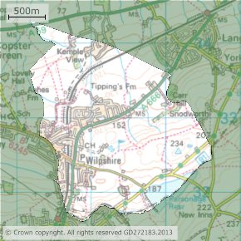

This ‘Rough guide’ of the boundary line starts from the Wilpshire Parish Council meeting place at Wilpshire Methodist Church.
The solid boundary lines on the following maps show where Wilpshire intersects with other Parishes and other Local Authorities.

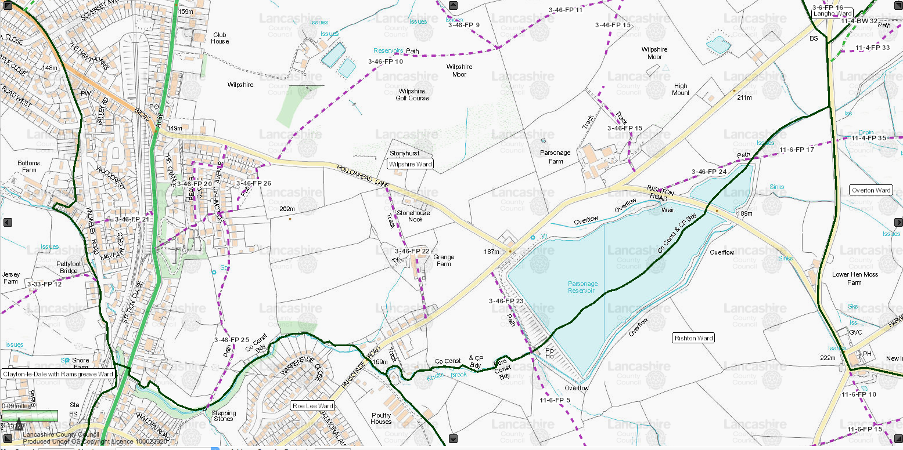

So, from Wilpshire Methodist Church and then heading down Knowsley Road our boundary is in contact with Clayton le dale and Ramsgreave wards; shortly after we pass under the railway bridge it takes an abrupt turn east across Showley Brook at Blackburn and then generally follows the brook upstream past Warrenside Close in Blackburn, crossing over Parsonage Road and following Knotts Brook and then across the centre of Parsonage Reservoir; continuing to York Road, here touching Langho Ward and Hyndburn.

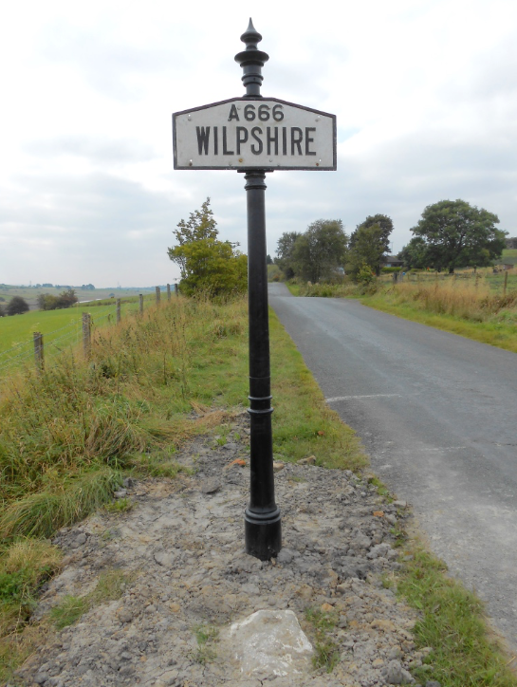

The above picture is at York Road-Wilpshire’s heritage A666 boundary sign rehomed on the boundary line adjacent to a flat boundary stone in the foreground.

From this sign and passing to the west of Little Snodworth, the boundary follows the stream down to Carr Hall cutting through the fields to the A666 at the shared Wilpshire & Langho/Billington boundary stone as shown in the picture below.
(Recently repainted by Wilpshire Parish Council)

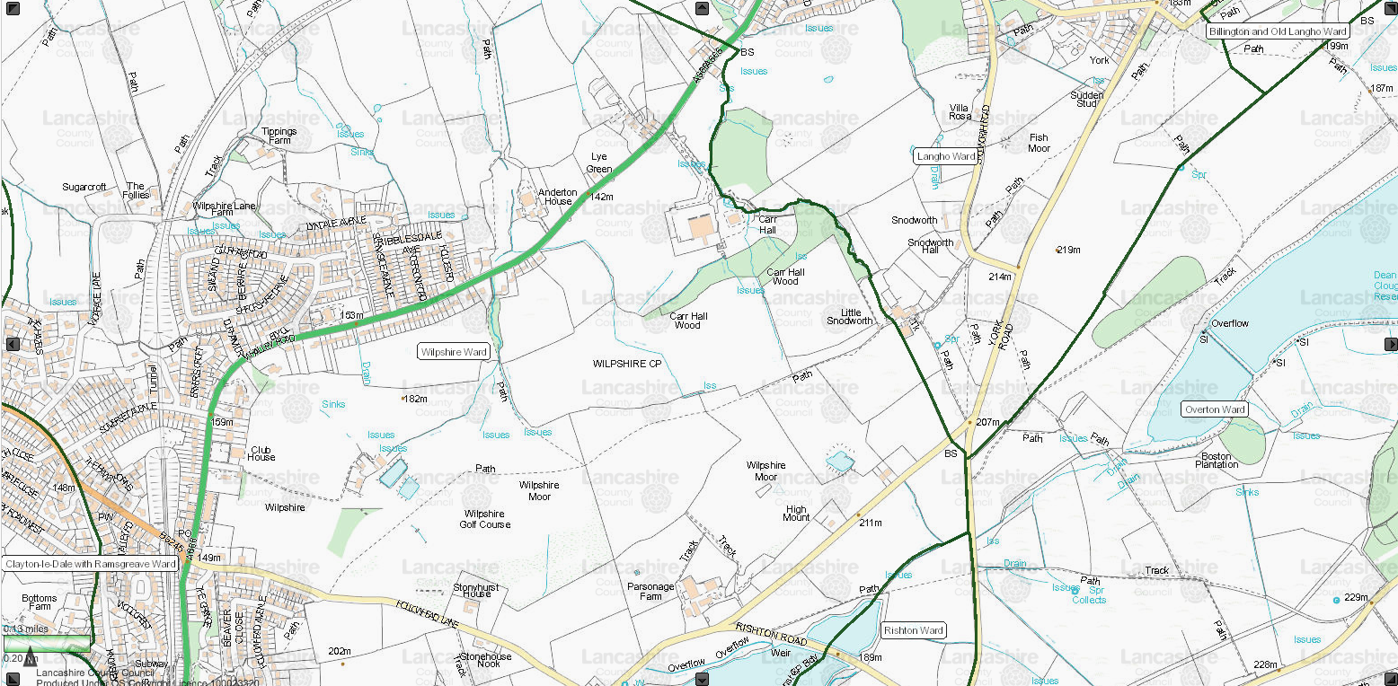

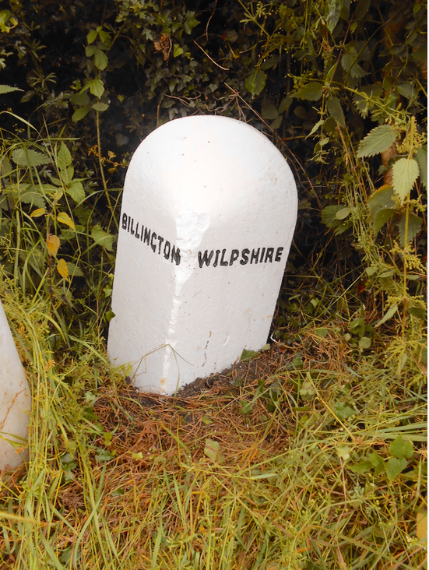

Then cutting across the A666 on a long diagonal line our boundary crosses fields and through the centre of ’the Rydings’ with Kemple View Hospital within Wilpshire and the ‘Sanctuary of Healing’ on the Langho /Billington side, ultimately crossing the A59 at it’s most northerly point.

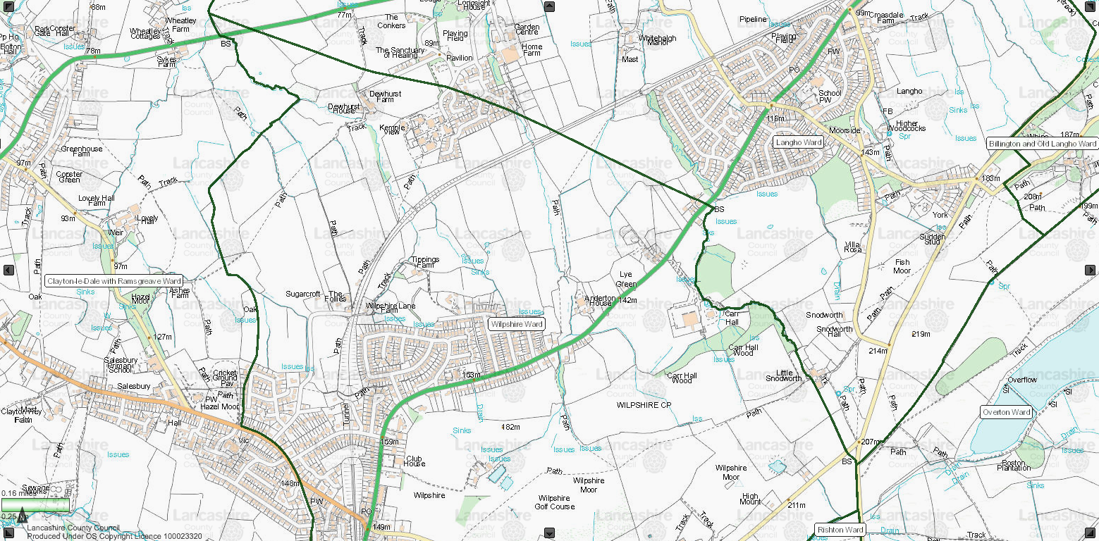

Returning and recrossing the A59 (on a bridge over the brook) is situated the Wilpshire & Salesbury boundary stone (also renovated by Wilpshire Parish Council).

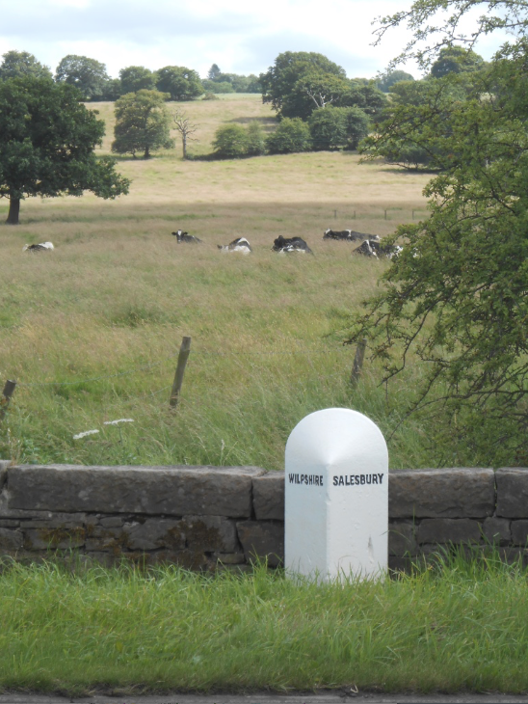

From here our boundary zig-zags uphill through the fields and through the rear gardens of the Hazels adjacent to Salesbury Common; turning abruptly east at Ribchester Road, (Where Wilpshire, Salesbury and Clayton le dale meet), crossing Ribchester Road at the Knowsley Road junction thence back to our starting point at Wilpshire Methodist Church.

Mario –(Maps and related Information Online)-LCC
This is a Lancashire County Council online facility and contains a wealth of information.
The maps in the above article ‘Rough guide’ of Wilpshire’s boundary were taken from ‘Mario’ and can be seen in more detail as required on the site. (Clicking on Ward boundary on the Local government information on the left-hand side menu and drilling/zooming down/moving map to the area of interest).
The maps can be overlaid with information such as Public Rights of Way, Ward and Council boundaries, Crime and Public safety, Highways and Transport, Aerial photographs and Historic maps.

